**Group 5**

First Chance Saloon

Dating Website

Mary Cronin - 0510661

Adrian O Sullivan- 16230124

Deirdre Shanahan- 16230256

Cornelius Broderick – 9119124

Contents

Introduction 3

High Level functionality 4

User Stories 4

Data Flow Diagram 7

Entity Relationship Diagram 8

Web Page Mock Ups 9

Database Tables 15

Process List: 18

High level Process List Activity Diagram 18

Use Case System and Activity Diagram of Web dating site 19

Full Activity Diagram 20

Process Tables 21

Bibliography 28

# Introduction

This project will be to produce an online dating agency. The basic functionality will allow users to register and describe themselves, as well as browse other users and perform various searches (e.g. list all men over 25 who listed swimming as a hobby).

# High Level functionality

This website will support multiple users who are seeking a relationship. They will have two roles:

* Person initiating a contact
* Person receiving a request for a contact

The system will facilitate the communications between these two roles. The system will also support an administrator role whose function is to act as a mediator between users and will have the power to block or bar users. The system will monitor communications between users and automatically block messages that include inappropriate content.

Users will register their email address along with some personal details when setting up a new account. Once this is complete they will have access to do the following:

* Receive recommendations for people who match their profile
* Complete searches of the database to find people
* Communicate with other users
* Maintain account by updating profile, contact details or password
* Report inappropriate behaviour

For our website design we have chosen to take a minimalist approach in the number of questions being asked of the user. Based on our research we have concluded that physical attractiveness plays a major part in initial encounters (Swami & Furnham, 2008). The website will be limited geographically to Ireland.

## User Stories

|  |  |  |  |
| --- | --- | --- | --- |
| *US001* | **User Profile** | *Priority* | **High** |
| *As A* | User | *Estimate* | Medium |
| *I would like* | To be able to register a user profile which includes a description of myself and indicating my preferences for a partner | | |
| *Because* | I am seeking a relationship with another person | | |
| *Acceptance Criteria* | * I can record the following details:   + Name   + Email   + Date of birth   + Gender   + Preferred Partner gender   + Password   + Location (nearest City)   + Seeking Age Group   + Distance Will Travel   + Relationship Type   + Photo * I have the option of recording the following:   + Interests/Hobbies   + Bio * User can only create a profile if they are over the age of 18 * Passwords are ranked in order of secureness * Only one profile per email address supported | | |

|  |  |  |  |
| --- | --- | --- | --- |
| *US002* | **Profile Matching List** | *Priority* | **High** |
| *As A* | User | *Estimate* | High |
| *I would like* | To be able to search for specific criteria | | |
| *Because* | I would like to be able to complete broad searches for potential partners | | |
| *Acceptance Criteria* | * I can complete searches based on gender preference, age, hobbies or interests * I can find potential matches based on criteria above * The results are presented in photographic format * I can indicate my interest in the listed photographs | | |

|  |  |  |  |
| --- | --- | --- | --- |
| *US003* | **Profile Matching List** | *Priority* | **High** |
| *As A* | User | *Estimate* | **High** |
| *I would like* | To be able to see people who are matched to my profile. | | |
| *Because* | I would like to see top potential partner | | |
| *Acceptance Criteria* | * Based on my profile I can see a list of matching potential partners * Location is included in the ranking with a high weighting * I can view more details of a match and from there initiate contact * I can mark a potential match as “like , maybe, goodbye”. * If I select a Goodbye, I am never presented with that profile again * This list is presented to me when I log in * I can report inappropriate behaviour | | |

|  |  |  |  |
| --- | --- | --- | --- |
| *US004* | **Initiate Request** | *Priority* | **High** |
| *As A* | User | *Estimate* | Medium |
| *I would like* | Initiate chat with a person | | |
| *Because* | I would like to be able to request a chat with a potential match | | |
| *Acceptance Criteria* | * I can establish two-way conversation with another user * I can see chat history | | |

|  |  |  |  |
| --- | --- | --- | --- |
| *US005* | **Receive Request** | *Priority* | **High** |
| *As A* | User | *Estimate* | Low |
| *I would like* | To be able to see a list of requests from other users | | |
| *Because* | I need to see potential partners who are interested in meeting me | | |
| *Acceptance Criteria* | * List of requests are visible and I can view their profile | | |

|  |  |  |  |
| --- | --- | --- | --- |
| *US006* | **Moderation** | *Priority* | **Medium** |
| *As A* | System Administrator | *Estimate* | Low |
| *I would like* | To be able to oversee communications between users and block illegal or explicit content. | | |
| *Because* | The web site has a duty of care to their users | | |
| *Acceptance Criteria* | * A black list of words is maintained * Content containing black listed words is automatically blocked * The request will expire after a number of days * Option to report inappropriate content is available to users * Option to ban users from using the site | | |

|  |  |  |  |
| --- | --- | --- | --- |
| *US007* | **Moderation** | *Priority* | **High** |
| *As A* | System Administrator | *Estimate* | Low |
| *I would like* | Receive and process a notification of inappropriate behaviour from a user | | |
| *Because* | The web site has a duty of care to their users | | |
| *Acceptance Criteria* | * Users can be temporarily blocked from logging into the system for a period of time * User can be blocked from communicating with another specific user * User can be permanently blocked from using the system | | |

|  |  |  |  |
| --- | --- | --- | --- |
| *US008* | **Account destruction** | *Priority* | **Medium** |
| *As A* | User | *Estimate* | Low |
| *I would like* | To be able to request that my account is removed from the system | | |
| *Because* | GDPR compliance | | |
| *Acceptance Criteria* | * User details including all communications from that user are removed from the system | | |

|  |  |  |  |
| --- | --- | --- | --- |
| *US009* | **Password reset** | *Priority* | **High** |
| *As A* | User | *Estimate* | Low |
| *I would like* | To be able to reset my password | | |
| *Because* | I forgot my password | | |
| *Acceptance Criteria* | * Other users cannot reset my password | | |

|  |  |  |  |
| --- | --- | --- | --- |
| *US0010* | **Security** | *Priority* | **High** |
| *As A* | System administrator | *Estimate* | Medium |
| *I would like* | To have security built into the website to prevent Denial of Service (Dos) and other forms of malicious code from being stored in the database | | |
| *Because* | I want to ensure availability of the website to our users | | |
| *Acceptance Criteria* | * SQL Injection attacks are blocked * Malicious code is prevented from being added to the database * Users cannot initiate any form on the site without first having a profile * Users must communicate using the HTTPS protocol (if this is possible using the UL site) | | |

# Data Flow Diagram

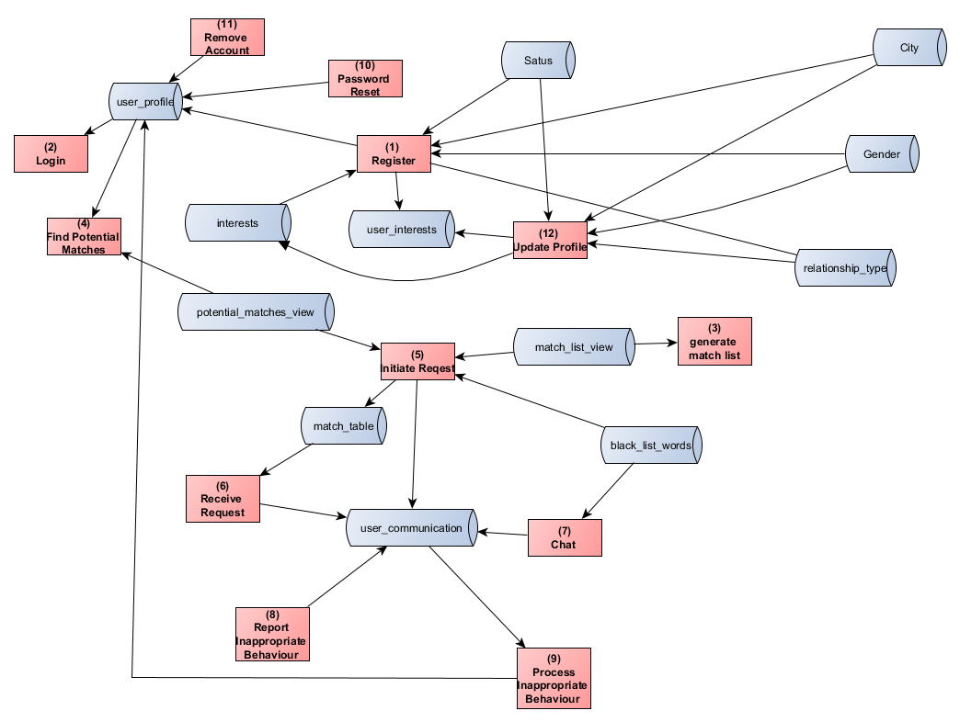

# Entity Relationship Diagram

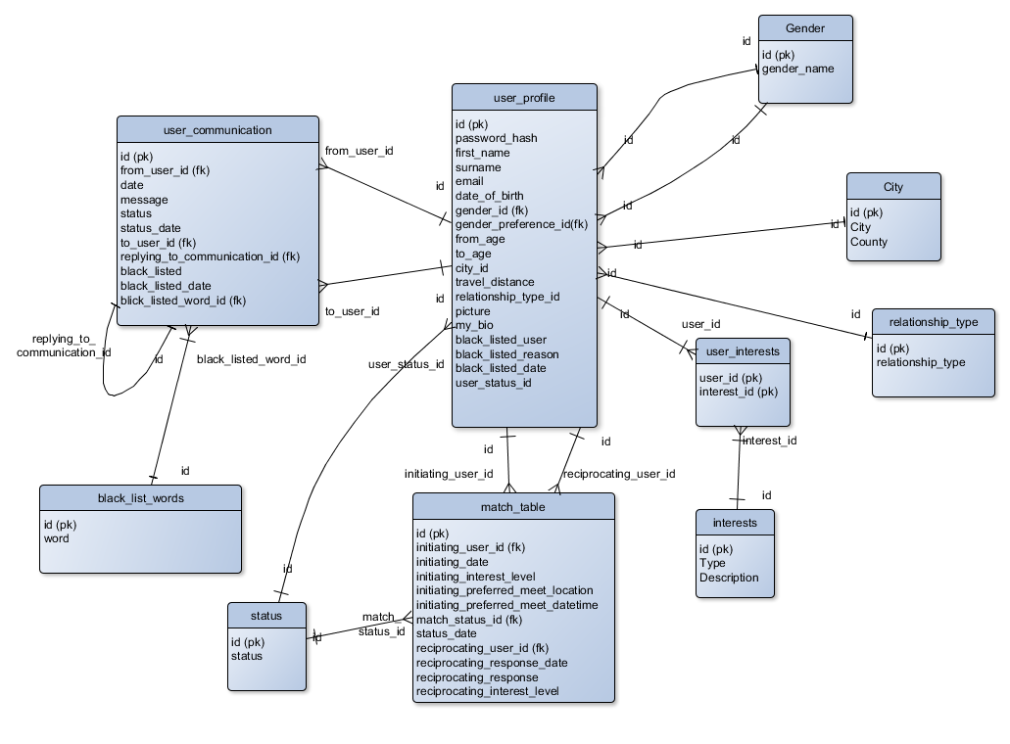

# Web Page Mock Ups

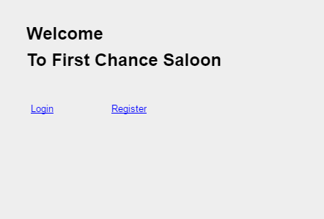

Figure - Welcome Page

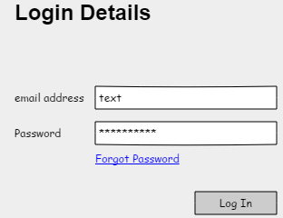

Figure - Login

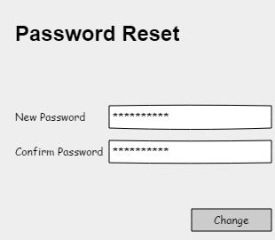

Figure - Password Reset

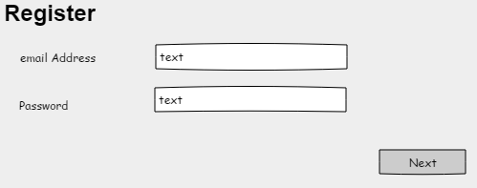

Figure - Register

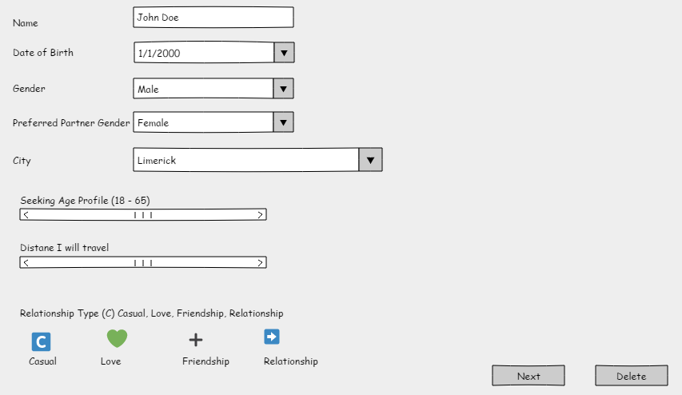

Figure – My Profile Page One

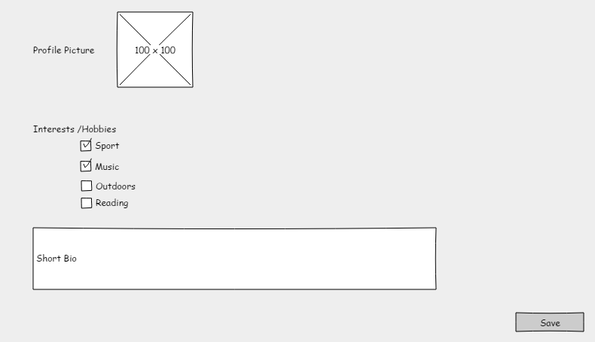

Figure – My Profile Page Two

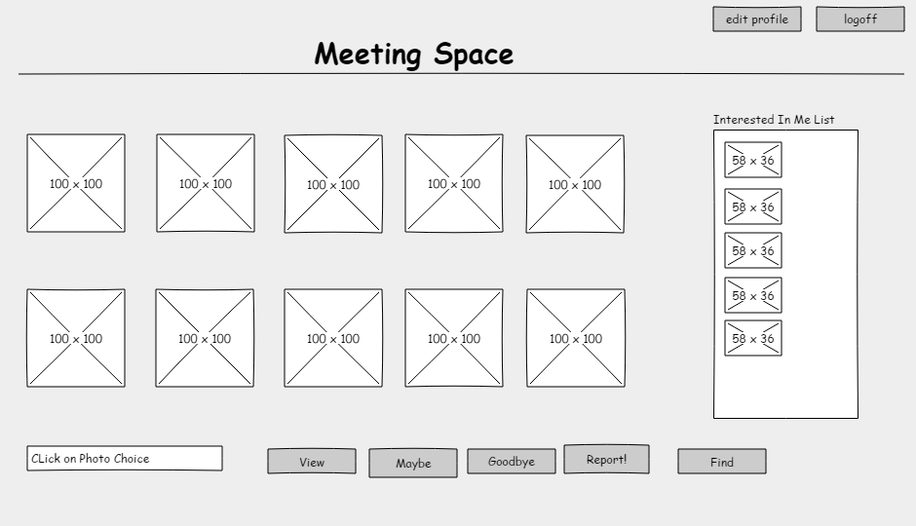

Figure - Meeting Space

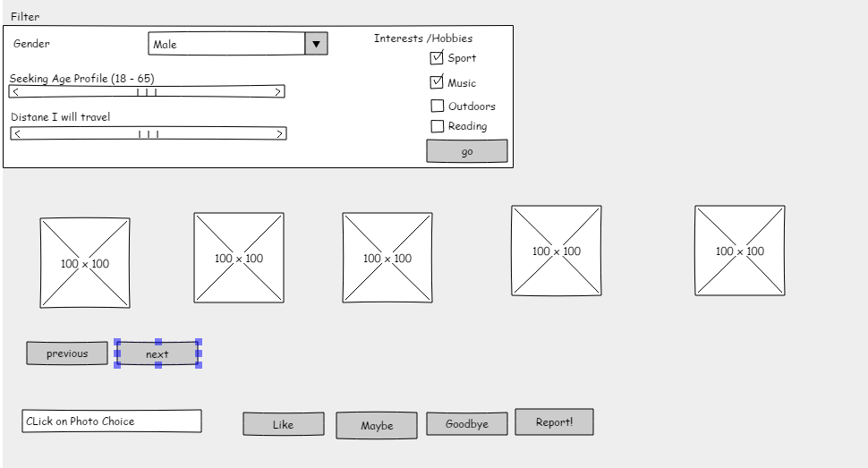

Figure - Search

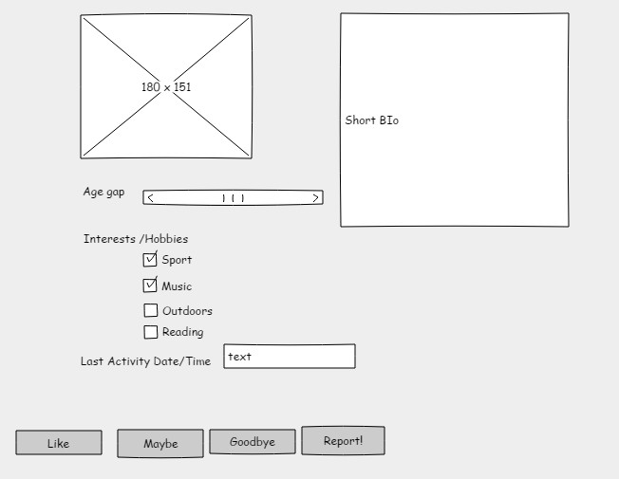

Figure - View Match Profile

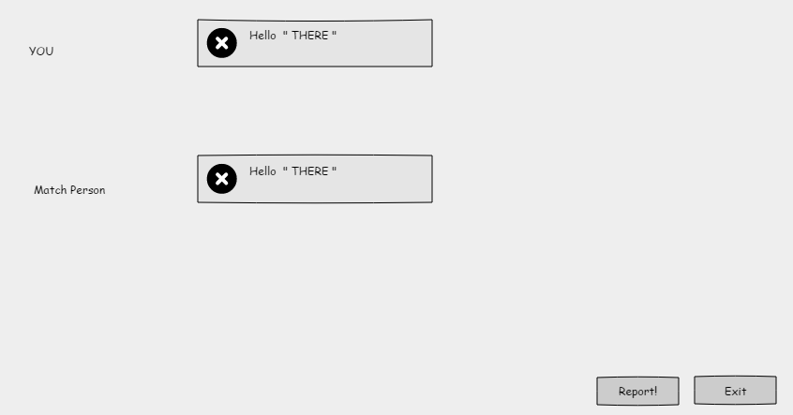

Figure - Chat Line

# Database Tables

Table 1 user_profile

|  |  |  |  |
| --- | --- | --- | --- |
| **Field** | **Type** | **Primary** | **Foreign** |
| id | int | Yes |  |
| password_hash | Varchar(200) |  |  |
| first_name | Varchar(50) |  |  |
| surname | Varchar(100) |  |  |
| email | Varchar(100) |  |  |
| date_of_birth | date |  |  |
| gender_id | bool |  | yes |
| gender_preference_id | Varchar(20) |  | yes |
| From_age | int |  |  |
| To_age | int |  |  |
| City_id | int |  |  |
| county | Varchar(100) |  |  |
| Travel_distance | int |  |  |
| Relationship_type_id | int |  |  |
| picture | blob |  |  |
| my_bio | Varchar(1000) |  |  |
| Black_listed_user | bool |  |  |
| Black_listed_reason | Varchar(100) |  |  |
| Black_listed_date | date |  |  |
| User_status_id | int |  |  |

Table 2 match_table

|  |  |  |  |
| --- | --- | --- | --- |
| **Field** | **Type** | **Primary** | **Foreign Key** |
| id | int | yes |  |
| Initiating_user_id | int |  | yes |
| Initiation_date | datetime |  |  |
| Initiation_interest_level | int |  |  |
| Initiation_prefered_meet_location | Varchar(100) |  |  |
| Initiating_preferred_meet_datetime | datetime |  |  |
| Match_status_id | int |  | yes |
| Status_date | datetime |  |  |
| Reciprocating_user_id | int |  | yes |
| Reciprocating_response_date | datetime |  |  |
| Reciprocating_response | Varchar(2000) |  |  |
| Reciprocating_interest_level | int |  |  |

Table 3 user_communication

|  |  |  |  |
| --- | --- | --- | --- |
| **Field** | **Type** | **Primary** | **foreign** |
| id | int | Yes |  |
| from_user_id | int |  | yes |
| date | datetime |  |  |
| message | Varchar(150) |  |  |
| status | Varchar(20) |  |  |
| Status_date | date |  |  |
| To_user_id | int |  | yes |
| Replying_to_communication_id | int |  | yes |
| Black_listed | bool |  |  |
| Black_listed_date | datetime |  |  |
| Black_listed_word_id | int |  | yes |

Table 4 black_list_words

|  |  |  |
| --- | --- | --- |
| **Field** | **Type** | **Primary** |
| id | int | yes |
| word | Varchar(100) |  |

Table 5 user_interests

|  |  |  |
| --- | --- | --- |
| **Field** | **Type** | **Primary** |
| User_id | int | yes |
| Interest_id | int | yes |

Table 6 interests

|  |  |  |
| --- | --- | --- |
| **Field** | **Type** | **Primary** |
| id | int | yes |
| type | Varchar(100) |  |
| description | Varchar(200) |  |

Table 7 Gender Table

|  |  |  |
| --- | --- | --- |
| **Field** | **Type** | **Primary** |
| id | int | yes |
| Gender_name | Varchar(100) |  |

Table 8 city Table

|  |  |  |
| --- | --- | --- |
| **Field** | **Type** | **Primary** |
| id | int | yes |
| city | Varchar(200) |  |
| county | Varchar(200) |  |

Table 9 Relationship Type

|  |  |  |
| --- | --- | --- |
| **Field** | **Type** | **Primary** |
| id | int | yes |
| Relationship_type | Varchar(200) |  |

Table 10 Status

|  |  |  |
| --- | --- | --- |
| **Field** | **Type** | **Primary** |
| id | int | yes |
| status | Varchar(200) |  |

# Process List:

## High level Process List Activity Diagram

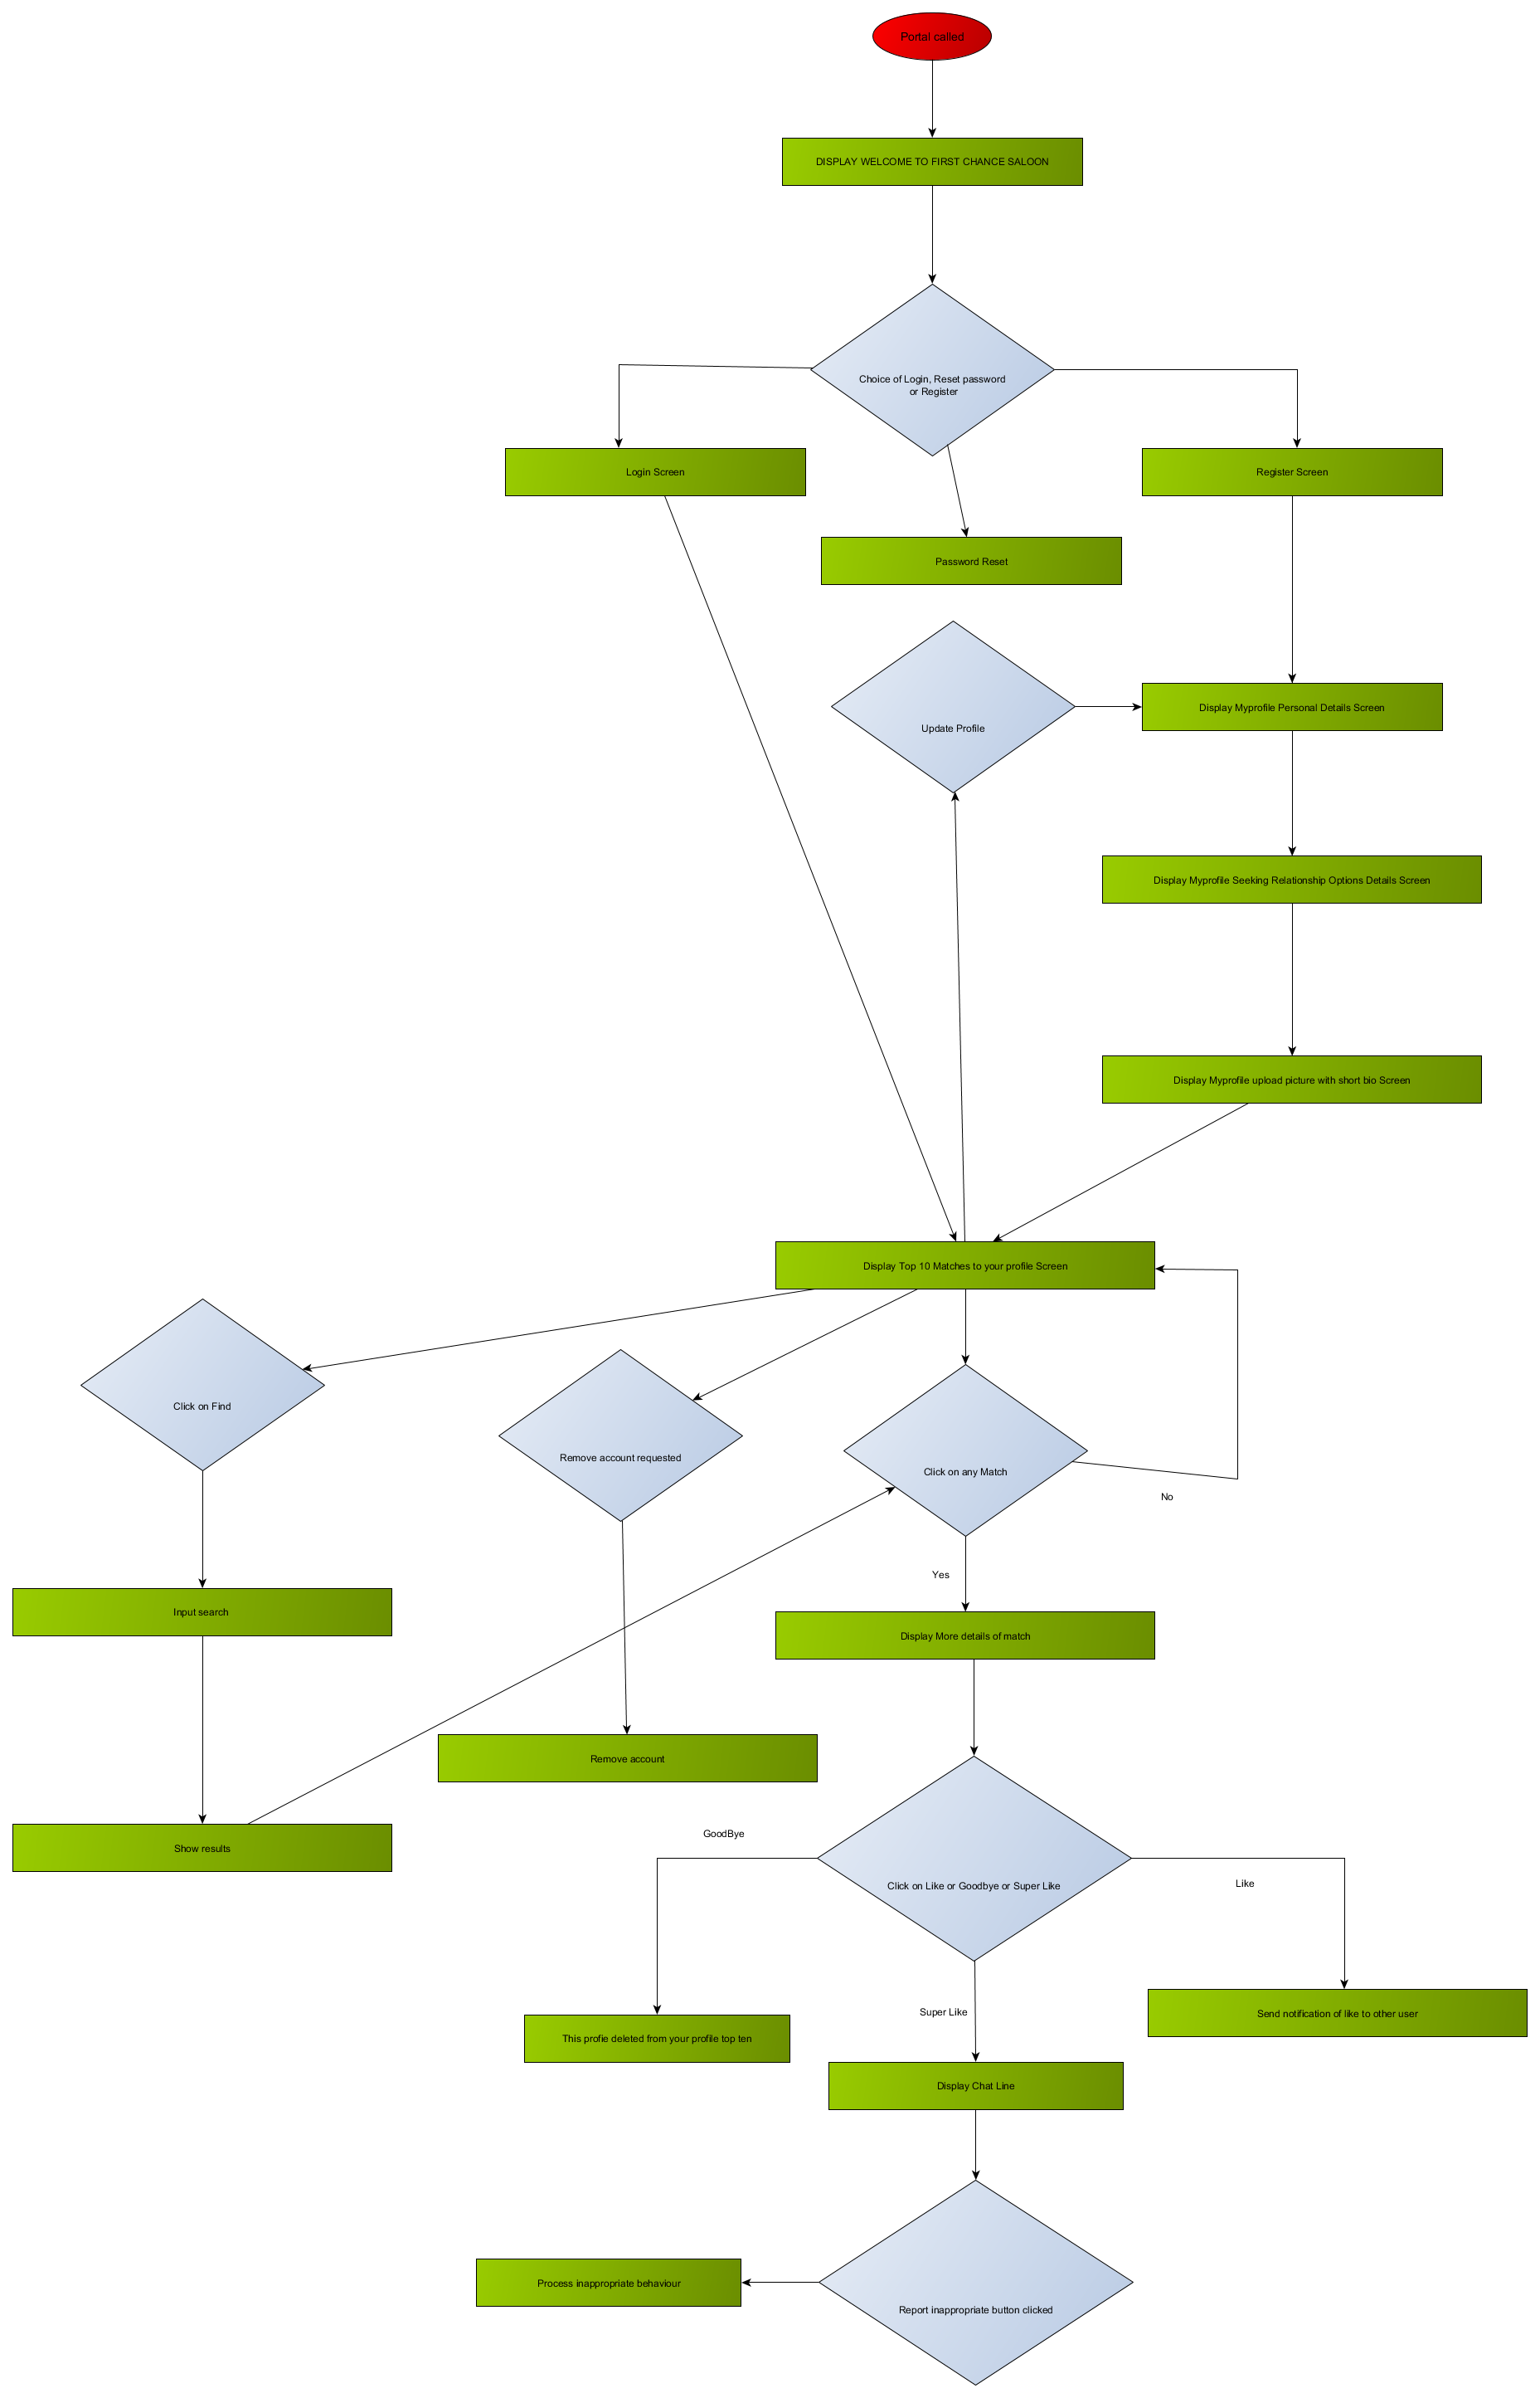

## Use Case System and Activity Diagram of Web dating site

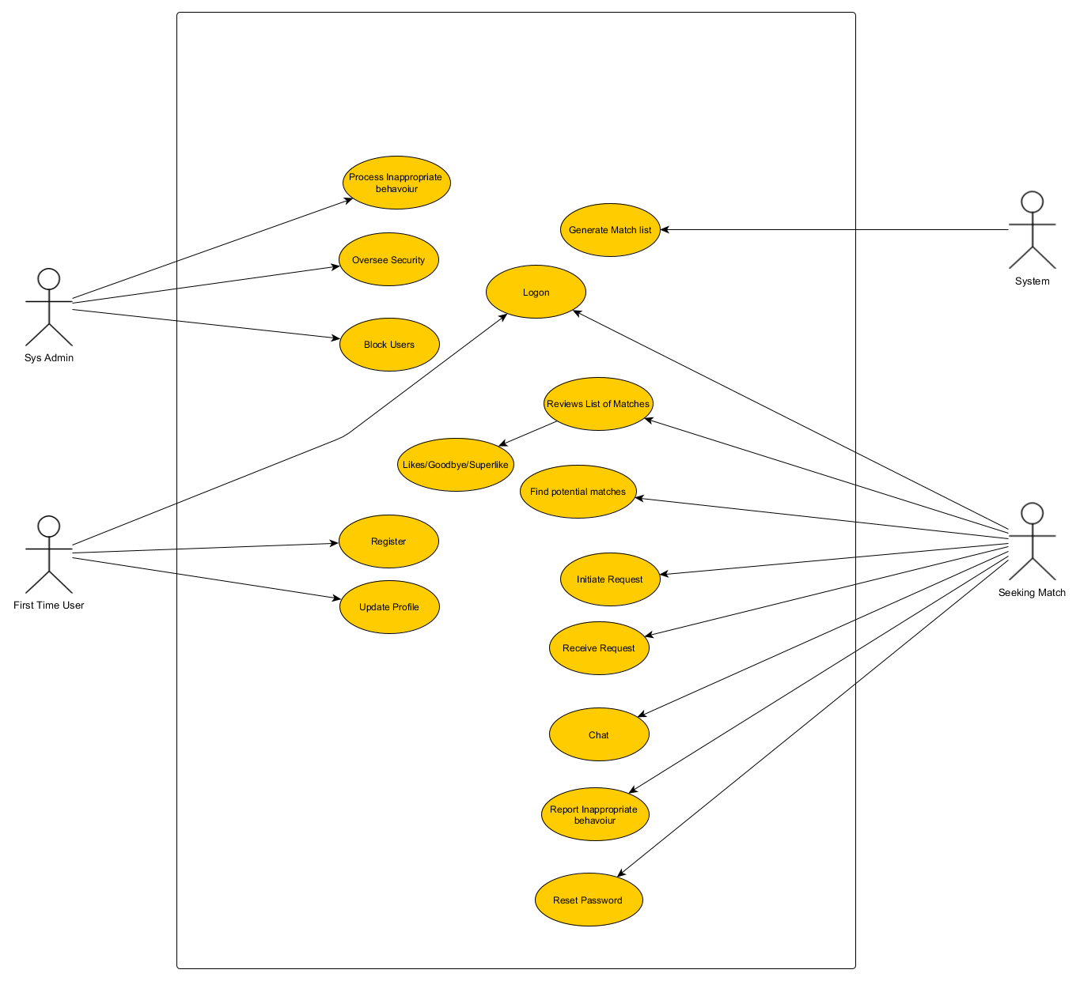

## Full Activity Diagram

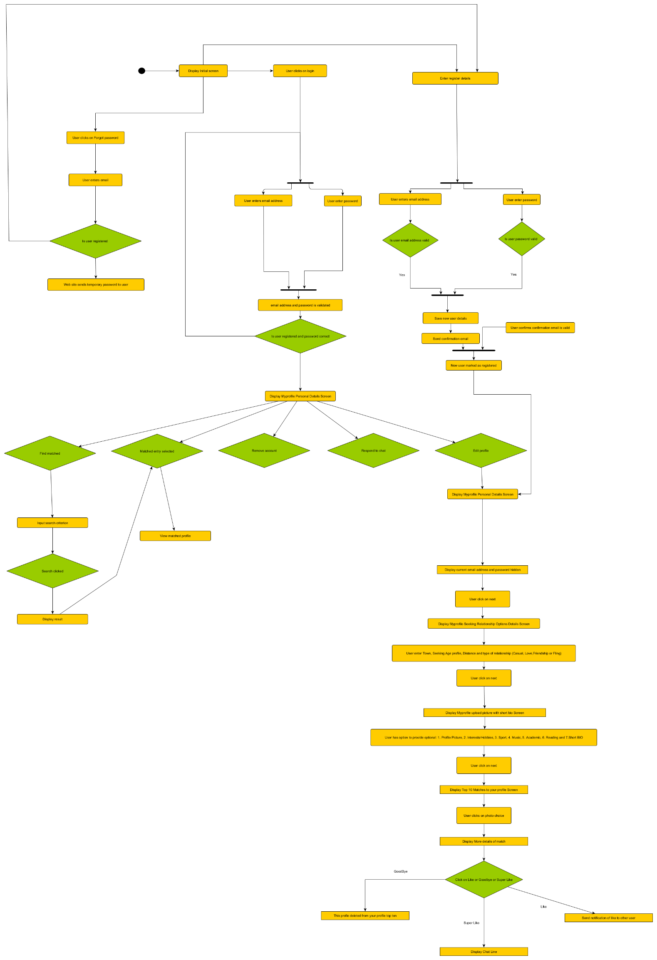

## Process Tables

|  |  |
| --- | --- |
| Process # | **1** |
| Title | To be able to register a user profile |
| Brief Description | User can create an account |
| Inputs | * Name * Email * Date of birth * Gender * Preferred Partner Gender * Password * Location (nearest City) * Photo * I have the option of recording the following:   + Interests   + Hobbies   + Type of relationship   + Age profile of partner   + User can only create a profile if they are over the age of 18   + Passwords are ranked in order of secureness   + Only one profile per email address  supported |
| Detailed Description | Add user details to the User_profile Table and user_interests table |
| Output | An insert into user_profile, user_interest |

|  |  |
| --- | --- |
| Process # | **2** |
| Title | To be able to update their user profile |
| Brief Description | User can change their profile details |
| Inputs | * Name * Email * Date of birth * Gender * Preferred Partner Gender * Location (nearest City) * Photo * I have the option of recording the following:   + Interests   + Hobbies   + Type of relationship   + Age profile of partner   + User can only create a profile if they are over the age of 18   + Passwords are ranked in order of secureness   + Only one profile per email address  supported |
| Detailed Description | Update user details to the User Table and user_interests |
| Output | An insert into user_profile, user_interest |

|  |  |
| --- | --- |
| Process # | **3** |
| Title | Logon |
| Brief Description | User can Logon to the system |
| Inputs | * + Email address and password |
| Detailed Description | User enters their email and password, these are checked against the entries in the user_table and if they match then the user is allowed into the system, if not they are presented with a message  After 4 logon attempts, they are blocked from using the screen |
| Output | Match space screen if logon successful |

|  |  |
| --- | --- |
| Process# | **4** |
| Title | Search for specific criteria |
| Brief Description | The web site will automatically search and find matching profiles |
| Inputs | The inputs are the values which the user has stored in user_interests and interest tables. |
| Detailed Description | A broad search for potential partners completed based on profile preferences which include gender, age range and interests. |
| Output | Will generate an entry in the match_table with the users which match criteria. |

|  |  |
| --- | --- |
| Process # | **5** |
| Title | Users matched to my preferences |
| Brief Description | To be able to see a list of people who are matched to profile |
| Inputs | The user’s selection from the findings of the matching profiles |
| Detailed Description | The user can view the list of photographs |
| Output | Photograph list |

|  |  |
| --- | --- |
| Process# | **6** |
| Title | Find users |
| Brief Description | User can enter criteria and get a list of pictures matching this criteria |
| Inputs | Gender, Age Range, Distance & Hobbies |
| Detailed Description | Based on the users inputs, the system will return a list of matching pictures and the user can then choose an action such as Like, Maybe, Goodbye or Report. |
| Output | A list of matching photographs |
|  |  |

|  |  |
| --- | --- |
| Process # | **7** |
| Title | View Profile |
| Brief Description | Allows user to view in more detail a potential match |
| Inputs | User clicks on the View Button |
| Detail Description | When the button is clicked, the Match screen is presented so that they can view the persons details which include interests, age, bio, etc. |
| Output | Match screen |

|  |  |
| --- | --- |
| Process # | 8 |
| Title | Maybe clicked |
| Brief Description | Allows user to indicate that they may be interested in chatting later |
| Inputs | User clicks on the maybe button |
| Detail Description | When the button is clicked, the profile selected is marked to be kept on the top match list |
| Output | Meeting Space screen |

|  |  |
| --- | --- |
| Process # | 9 |
| Title | Goodbye button |
| Brief Description | Allows user to indicate that they are not interested |
| Inputs | User clicks on the goodbye button |
| Detail Description | When the button is clicked, the profile selected is marked so that it is never presented to the user again |
| Output | Meeting Space screen |

|  |  |
| --- | --- |
| Process # | 10 |
| Title | List of people interested in chatting with me |
| Brief Description | To be able to see a list of people interested in chatting with me |
| Inputs | List of photographs |
| Detailed Description | * When a user initiates a chat, the receiving user can see in their image in a list * The user can choose to view their profile and decide what to do next |
| Output | User has visibility to details of people interested in initiating chat |

|  |  |
| --- | --- |
| Process # | 11 |
| Title | Handle inappropriate behaviour |
| Brief Description | Allow user to notify the system administrator of inappropriate behaviour |
| Input | Chat message from user |
| Detailed Description | Receive message from user, review the offending message and if deemed inappropriate notify the offender and if they persist with inappropriate behaviour they are blocked from accessing the system |
| Output | Offending user notified or blocked |

|  |  |
| --- | --- |
| Process # | 12 |
| Title | Account Deletion |
| Brief description | Allow user to delete their account |
| Inputs | User clicks on the Delete account and confirms deletion |
| Detailed Description | User details including all communications from that user are removed from the system |
| Output | Database entries deleted |

|  |  |
| --- | --- |
| Process # | 13 |
| Title | Password reset |
| Brief Description | To be able to reset my password |
| Inputs | User clicks on forgot my password |
| Detailed Description | Email sent to user with a link to reset the password, if user presses on the link, they are presented with a screen to allow the password change |
| Output | Password changed |

|  |  |
| --- | --- |
| Process # | 14 |
| Title | Logoff |
| Brief Description | User clicks on the Logoff button |
| Inputs | Button click |
| Detailed Description | Welcome screen is displayed and the user cannot enter the system again without entering their credentials |
| Output | Welcome screen |

# Bibliography

Swami, V., & Furnham, A. (2008). *The psychology of physical attraction*. New York, NY: Routledge/Taylor & Francis Group.